Dental Health Position

Health and Dental Care are two of the most important things contributing to a person’s physical and emotional health. The question is: is everyone financially capable of providing this care for themselves, let alone their families? The answer is no; in society today not only Dental Care but Health Care alone is just way too expensive for many individuals to afford, so they may choose to go without. This is one of the rashest decisions a person or household could make. It is clear that no one person could survive without healthcare; people will get sick, get infections, get cavities, and contract diseases. It’s inevitable that without the care they need many lives will be needlessly lost.
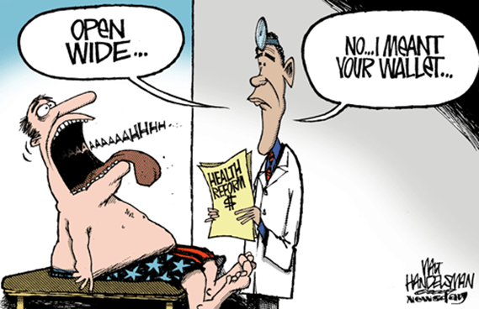
Affordable healthcare has been widely considered in the United States for the past few years. It is left unanswered though, how dental care will be included when looking into overall healthcare. Little information has been given on dental health care and the importance of including it in new health laws. This poses a huge problem for many families and individuals whom believe dental health goes hand in hand with overall health. While ideas of dental health importance and how it will be implemented remain inconsistent with what is being done for change, Americans still have no idea how their dental coverage will be affected by new laws.
According to Dental Health Magazine American families pay about $19,393 per year for health care coverage. Even with this health coverage it is still found that around 60% of personal bankruptcies are directly linked to dental or medical costs. Americans spend twice as much for health care as the Japanese, the Canadians or the Swedish. So why is this? Why can American’s not afford Dental Care and what can be done about it?
Creating affordable healthcare has been one of Barack Obama’s top priorities since he was elected President of the United States in 2008. “Everybody understands the desperation that people feel when they're sick. And I think everybody is profoundly sympathetic and wants to make sure that we have a system that works for all Americans,” explains President Obama. He carried out the idea of the Affordable Care Act, otherwise known as the Healthcare Reform or Obama Care. This is in an effort to make healthcare more affordable to Americans. “The Affordable Care Act is a health care law that aims to improve our current health care system by increasing access to health coverage for Americans and introducing new protections for people who have health insurance.”(What is para. 2) The law is supposed to cover more out-of-pocket expenses for individuals with existing insurance policies as well as helping those with pre-existing conditions whom have been dropped from their insurance get the care they need.
How dental coverage affected by the new health care reform? Is it even included at all? Is dental care getting the attention it should be in the healthcare reform discussion? The easy answer to these questions is no, when looking into the Healthcare Reform there is little to no information given concerning dental care, when in actuality this is a huge issue within the healthcare issue itself. Yet dental care rests as the most common unmet healthcare need in the United States today. CNN's Dr. Sanjay Gupta explains “For every one person without Healthcare Insurance, there is about two without Dental Insurance. That’s over 100 million people without any Dental insurance whatsoever.” With just under 50% of Americans without any dental coverage whatsoever, you would think this would be a little more focused on.
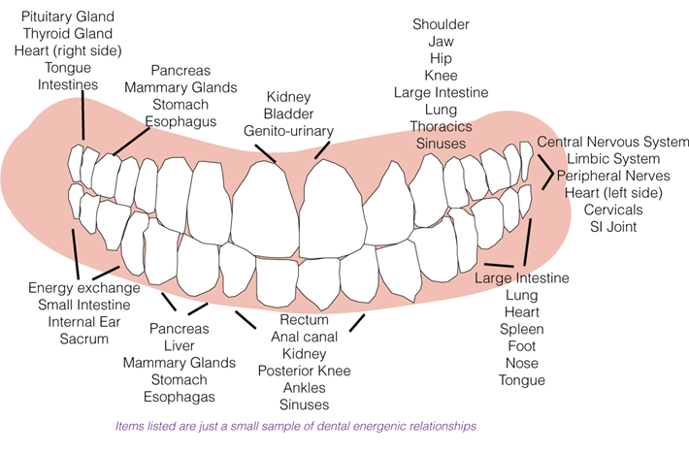
It is easy to think that a visit to the doctor is way more important that a visit to the dentist, but that is an incredibly misconceived idea. When looking at statistics, “tooth decay is five times as likely to be found in children as is asthma, which, like most common illnesses, is covered by health insurance. But at least 26 million children lack dental coverage” (Otto para. 2). “Among adults, oral cancer kills more Americans than cervical cancer, and research suggests that oral infections can affect pregnancy outcomes and complicate chronic diseases such as diabetes. Still, 82 million adults have no dental insurance” (Putting Teeth para. 3). Does that seem logical? Didn’t think so. Most Americans do not understand the fact that oral health and overall health are directly correlated.
The relationship between oral health and overall health is clearly apparent. So why is it that dental health is not a priority unless it is severe enough to put a life in danger? This remains a mystery to many dental-health experts as well as those being directly affected by the new health reform. It is crazy to think that a topic so large is being overlooked. "The mouth, is the only body part or essential organ that is excluded from policymakers' routine consideration of health and health care." Says Burton Edelstein, a professor of dentistry and health policy management at Columbia University (Otto para. 7).

One group that will be directly affected by the health care reform will be children. They will be covered more than any other age group and directly focused on by those carrying out this reform. When it comes to dental health care, this is the one portion of oral health that has been looked into more than anything else. “Each year, millions of productive work hours are lost due to dental diseases. Dental disease is also one of the leading causes of school absenteeism for children: Children miss 51 million hours of school due to dental problems” (How Dental Care para. 8).
The lack of insurance coverage has real consequences for American families. A heartbreaking example of untreated dental disease was the 2007 death of a 12-year-old named Deamonte living in Maryland. His death resulted from complications of a grave dental infection that spread to his brain. This infection could have been avoided had Deamonte received proper preventive dental care. “The cost of his hospitalization was estimated at $250,000. Had he gotten treatment earlier, the cost would have been closer to $80 — and he would have lived to see his 13th birthday” (Otto para. 7).
While children are extremely important, it is unfair to focus all on the young when there are some adults, even the elderly, which will continue to suffer with oral health issues. “The final reform bill includes oral healthcare among the minimum services available to individuals less than 21 years of age” (Uzdienski para. 2). So what about things like critical dental procedures that fall into the out-of-pocket expenses? This is just to be left alone for the individual to figure out? Those above the age of 21 should also be covered by these benefits. When focusing solely on children, it counteracts the importance of the rest of a family whom should also be covered by the same amount of benefits as those not considered an adult. The parents and grandparents are at a larger risk for dental decay because of nothing more than their age alone. “Workers lose 164 million work hours because of dental disease” (Otto para. 8). If the guardians were to be affected by an extreme dental case, it could take their lives, having a slippery slope effect on the children they are raising. “According to the Journal of Dental Education, oral-related illnesses account nationally for 3.6 million days of bed disability and 11.8 million days of restricted activity” (Roll call para. 8). The importance of overall oral health for a whole population is crucial.
There are a couple solutions that have been looked into concerning dental care. Something that needs to be done to help fix this issue would be to ensure that dental healthcare is included in the healthcare reform and in the discussion by making sure that the issue is kept visible in the House of Representatives and within the current election so dental health is properly represented. No one should have to go without the coverage they need and have to live with the immense pain of a cavity or decay causing physical pain and later damage to overall health. The only way to change the way oral health is being represented would be to change the way people see it as an issue. To show that overall health is connected to oral health will give a better perspective of this. Oral health may be looked at as a preventative object toward further health issues instead of seen as just treatment for little things such as cavities. This helps the topic feel more real and shows how it is a long term issue that most oversee. The American Dental Association has spoke of getting someone invested in this issue at the discussion table. A politician that is also worried about dental care and who pays attention to what needs to be done to join the political debate. Dentists and health experts must be involved in the discussion of healthcare within politics to keep it a point of interest.
One of the few actions that have currently been made toward the health reform involving dental care would be free/affordable dental clinics for those with low income. The free dental clinics will continue to help out and make a difference for so many people by making access to crucial care obtainable. Many of these clinics are run by schools and other corporations looking to enhance the professionals’ experience, they are spread widely around the United States. By funding them the public will get to keep these programs which do so much for those in poverty. This is one thing that is being discussed when it comes to including dental health in the act.
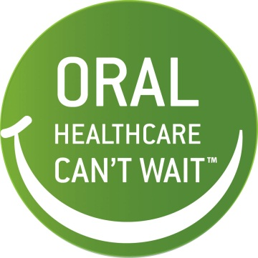
It is promised that schools and students studying dental hygiene will be given more funding in an effort to bring more dental professionals into the communities lacking them. Although this is a vague idea, with more dental experts there will be more opportunities for free dental care as well. If the health care act follows through with this plan there will still be easier to access dental care with more in the dental field, and society will be much better off.
Since dental health care has been overlooked, many “promises” given toward oral health care to this date have not been carried out so far. It is doubtful that they may ever be due to lack of funds. It is believed that with a somewhat minor government investment in three areas the government could make a significant improvement in the oral health of Americans. The American Dental Association states that the government should “mend the tattered Medicaid safety net by improving the dental Medicaid program, adequately fund proven oral disease prevention and wellness programs, and build the dental public health infrastructure, which includes recruiting and retaining dentists who are competent in public health practice” (Health Care Reform para. 3).
The issue of dental healthcare is clearly a problem that must be dealt with. It is ironic that the issue itself is just that, it is seen as not an issue at all. The fact that dental health is not being paid attention to by the government compared to overall medical health care is unreasonable. Dental care should not be pushed to the side unless we want things to spiral out of control with overall health. By looking into this issue more extensively and possibly entering a dental health expert into more of the election to keep the topic fresh in the media, society, and even the governments mind, it may be able to be taken care of with the current healthcare debate.

Works Cited

CNN. Perf. Dr. Sanjay Gupta. CNN. Cable News Network, n.d. Web. 15 Oct. 2012. <http://www.cnn.com/video/?/video/health/2009/08/05/reform.dental.care.cnn>.
Dental Health Awareness. N.d. Photograph. Web. 15 Oct. 2012. <http://www.dentalblogs.com/assets/dta-awareness-logo.jpg>.
Dental Importance Regarding Overall Health. N.d. Photograph. Web. 15 Oct. 2012. <http://www.nadiakiderman.org/wp-content/uploads/2012/06/dentalchart.gif>.
"Health Care Reform." - American Dental Association. N.p., n.d. Web. 15 Oct. 2012. <http://www.ada.org/2389.aspx>.
Health Care Reform Comic. N.d. Photograph. 7 Apr. 2012. Web. 15 Oct. 2012. <http://0.tqn.com/d/politicalhumor/1/7/x/q/2/obama-health-reform.gif>.
"How Dental Care Will Be Changed by Healthcare Reform." Dental Health Magazine. N.p., 24 Mar. 2010. Web. 14 Oct. 2012. <http://worldental.org/dental-news/how-dental-care-will-be-changed-by-healthcare-reform/1209/>.
Otto, Mary. "Putting Teeth in Healthcare Reform:Advocates Pursue Dental Issue." Washington Post. The Washington Post, 23 June 2009. Web. 14 Oct. 2012. <http://www.washingtonpost.com/wp-dyn/content/article/2009/06/22/AR2009062201658.html>.
Uzdienski, Lauren. "Conference Calendar." How Will Healthcare Reform Affect Dentistry? N.p., 23 Mar. 2010. Web. 15 Oct. 2012. <http://healthpointcapital.com/research/2010/03/23/how_will_healthcare_reform_affect_dentistry/>.
"What Is the Affordable Care Act?" Health Care and You. N.p., n.d. Web. 14 Oct. 2012. <http://www.healthcareandyou.org/what-is/>.

